实验7 组合模式

一. 实验目的
1．掌握组合模式的UML模型的设计和实现。

二．回答问题
1. 描述组合模式的定义以及对应UML结构类图
组合模式：组合多个对象形成树形结构以表示具有部分-整体关系的层次结构。组合模式让客户端可以统一对待单个对象和组合对象。
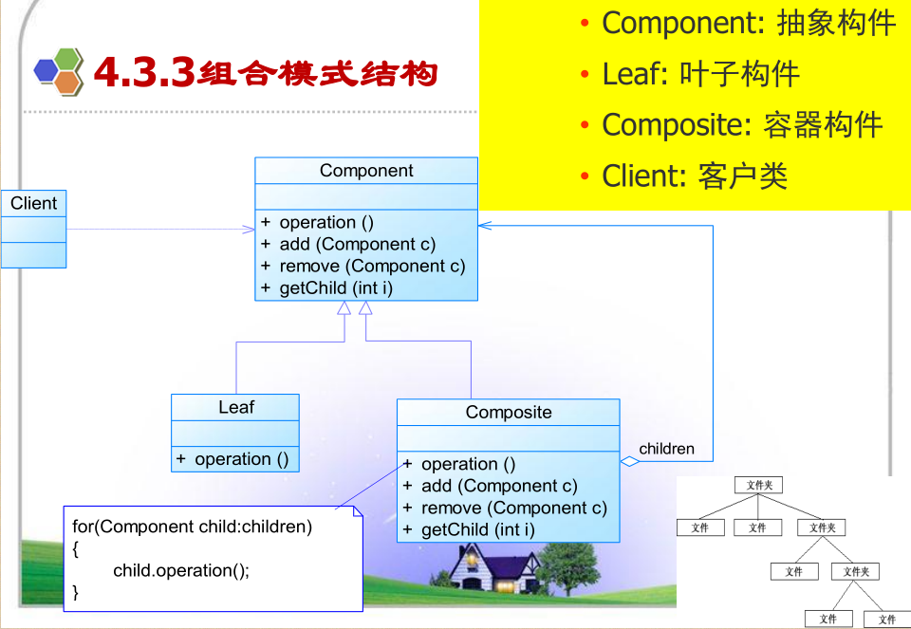

三．实验内容

（一）P122（3）
- 给出题目，画出UML设计模型类图，并解释各个角色。
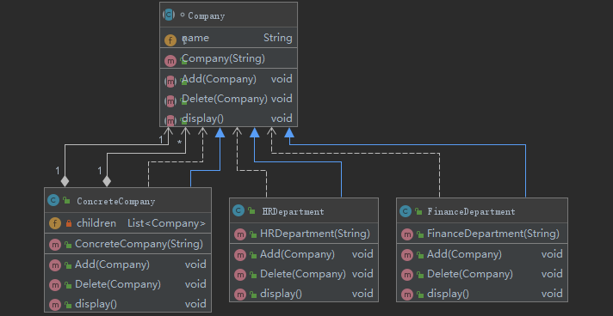
- 填空，实现各个类代码，并运行。

abstract class Company {
protected String name;
public Company(String name) {
this.name = name;
}
public abstract void Add(Company c);
public abstract void Delete(Company c);
public abstract void display();
}
import java.util.ArrayList;
import java.util.List;
public class ConcreteCompany extends Company {
private List<Company> children=new ArrayList<Company>();
public ConcreteCompany(String name) {
super(name);
}
@Override
public void Add(Company c) {
children.add(c);
}
@Override
public void Delete(Company c) {
children.remove(c);
}
@Override
public void display() {
System.out.println(name);
for(Object obj:children){
((Company)obj).display();
}
}
}
public class HRDepartment extends Company {
public HRDepartment(String name) {
super(name);
}
@Override
public void Add(Company c) {
}
@Override
public void Delete(Company c) {
}
@Override
public void display() {
System.out.println(name);
}
}
public class FinanceDepartment extends Company {
public FinanceDepartment(String name) {
super(name);
}
@Override
public void Add(Company c) {
}
@Override
public void Delete(Company c) {
}
@Override
public void display() {
System.out.println(name);
}
}
public class Client {
public static void main(String[] args){
ConcreteCompany root=new ConcreteCompany("北京总公司");
root.Add(new HRDepartment("总公司人力资源部"));
root.Add(new FinanceDepartment("总公司财务部"));
ConcreteCompany comp=new ConcreteCompany("上海分公司");
comp.Add(new HRDepartment("上海分公司人力资源部"));
comp.Add(new FinanceDepartment("上海分公司财务部"));
root.Add(comp);
ConcreteCompany comp1=new ConcreteCompany("南京办事处");
comp1.Add(new HRDepartment("南京办事处人力资源部"));
comp1.Add(new FinanceDepartment("南京办事处财务部"));
comp.Add(comp1);
root.display();
}
}
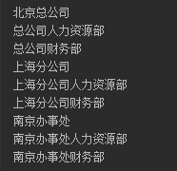

回答问题。

（二）水果盘
功能要求：在水果盘(Plate)中有一些水果，如苹果(Apple)、香蕉(Banana)、梨子(Pear)，当然大水果盘中还可以有小水果盘，现需要对盘中的水果进行遍历（吃eat），当然如果对一个水果盘执行“吃”方法，实际上就是吃其中的水果。使用组合模式模拟该场景，设计并实现。
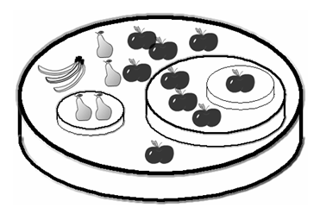
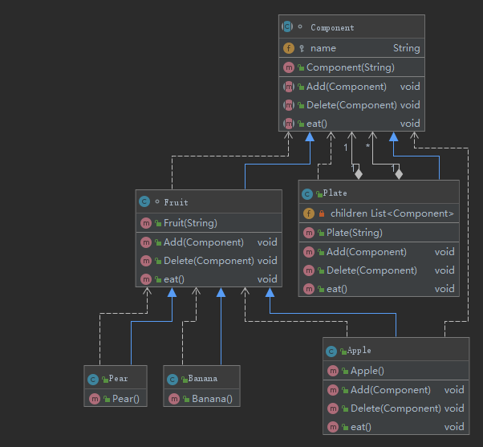
abstract class Component {
protected String name;
public Component(String name) {
this.name = name;
}
public abstract void Add(Component c);
public abstract void Delete(Component c);
public abstract void eat();
}
class Fruit extends Component {
public Fruit(String name) {
super(name);
}
@Override
public void Add(Component c) {
}
@Override
public void Delete(Component c) {
}
@Override
public void eat() {
System.out.println("吃掉了"+name);
}
}
public class Apple extends Fruit {
public Apple() {
super("苹果");
}
@Override
public void Add(Component c) {
super.Add(c);
}
@Override
public void Delete(Component c) {
super.Delete(c);
}
@Override
public void eat() {
super.eat();
}
}
public class Banana extends Fruit {
public Banana() {
super("香蕉");
}
}
public class Pear extends Fruit{
public Pear(){
super("梨");
}
}
import java.util.ArrayList;
import java.util.List;
public class Plate extends Component {
private List<Component> children=new ArrayList<Component>();
public Plate(String name) {
super(name);
}
@Override
public void Add(Component c) {
children.add(c);
}
@Override
public void Delete(Component c) {
}
@Override
public void eat() {
System.out.println("吃掉了"+name);
for(Component component:children){
component.eat();
}
}
}
public class Client {
public static void main(String[] args){
Plate root=new Plate("水果盘1");
root.Add(new Apple());
root.Add(new Apple());
root.Add(new Apple());
root.Add(new Apple());
root.Add(new Apple());
root.Add(new Banana());
root.Add(new Pear());
root.Add(new Pear());
Plate plate2=new Plate("水果盘2");
plate2.Add(new Apple());
plate2.Add(new Apple());
plate2.Add(new Apple());
root.Add(plate2);
Plate plate3=new Plate("水果盘3");
plate3.Add(new Apple());
plate2.Add(plate3);
Plate plate4=new Plate("水果盘4");
plate4.Add(new Pear());
plate4.Add(new Pear());
root.Add(plate4);
root.eat();
}
}
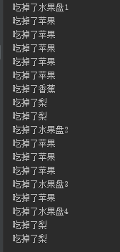

（三）教育机构组织结构（教材实训综合题3（3））
使用组合模式进行系统设计和实现。
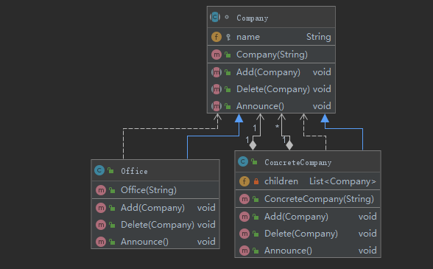

abstract class Company {
protected String name;
public Company(String name) {
this.name = name;
}
public abstract void Add(Company c);
public abstract void Delete(Company c);
public abstract void Announce();
}
import java.util.ArrayList;
import java.util.List;
public class ConcreteCompany extends Company {
private List<Company> children=new ArrayList<Company>();
public ConcreteCompany(String name) {
super(name);
}
@Override
public void Add(Company c) {
children.add(c);
}
@Override
public void Delete(Company c) {
children.remove(c);
}
@Override
public void Announce() {
System.out.println(name+"收到公文，并向下发公文");
for(Company company:children){
company.Announce();
}
}
}
public class Office extends Company {
public Office(String name) {
super(name);
}
@Override
public void Add(Company c) {
}
@Override
public void Delete(Company c) {
}
@Override
public void Announce() {
System.out.println(name+"收到公文");
}
}
public class Client {
public static void main(String[] args){
ConcreteCompany root=new ConcreteCompany("北京总部");
root.Add(new Office("教务办公室"));
root.Add(new Office("行政办公室"));
ConcreteCompany comp=new ConcreteCompany("湖南分校");
comp.Add(new Office("湖南分校教务办公室"));
comp.Add(new Office("湖南分校行政办公室"));
root.Add(comp);
ConcreteCompany comp1=new ConcreteCompany("长沙教学点");
comp1.Add(new Office("长沙教学点教务办公室"));
comp1.Add(new Office("长沙教学点教务办公室"));
comp.Add(comp1);
ConcreteCompany comp2=new ConcreteCompany("湘潭教学点");
comp2.Add(new Office("湘潭教学点教务办公室"));
comp2.Add(new Office("湘潭教学点教务办公室"));
comp.Add(comp2);
root.Announce();
}
}
